Results and Discussions

We evaluated 282 runs across seven benchmark campaigns to compare classical optimization with QAOA for microgrid snapshot allocation. The analysis distinguishes continuous power allocation from indivisible feeder switching because the two formulations permit different decisions. QAOA was evaluated as a simulated variational approach for small combinatorial instances. The separate 24-hour dynamic-dispatch model was solved using classical linear programming and is not included among the QAOA results. Throughout this section, J denotes the weighted penalty associated with unmet demand, and Z*₍disc₎ denotes the exact optimum of the corresponding discrete or discretized formulation; both are used as objective scores rather than physical power quantities.

1. Classical vs. Quantum Results
The classical baselines performed strongly on the tested instances. For continuous snapshot allocation, the priority-based greedy method gives an exact solution to the fractional-knapsack formulation, while classical mixed-integer linear programming (MILP) provides an optimization reference. For indivisible feeder switching, QAOA was evaluated on small cases. Its observed optimum-recovery rate depended on circuit settings and on the candidate-selection pipeline.
Table 1 summarizes the principal benchmark outcomes. We distinguish an optimal bitstring appearing in the raw measurement register from the production solver returning that optimum, because these are different success criteria.
Benchmark campaign | Runs | Reported aggregate result | Interpretation
Research pilot | 20 | 80.0% overall hit rate; QAOA p = 1: 50% | Mean runtime 0.45 s. The aggregate includes classical and QAOA solver modes; it is not a QAOA-only score.
QAOA depth sweep V1 (legacy) | 60 | 86.67% (52/60) reported hit rate | Mean runtime 1.23 s. The legacy selection pipeline could fail to return the best available candidate.
QAOA depth sweep V2 | 60 | 98.33% (59/60) raw-register optimum recovery, as reported | Mean runtime 1.18 s. This refers to optimum presence in raw measurements, not a verified production-output hit rate.
Candidate-selection post-fix audit | 8 | Best inspected candidate selected in 8/8 trials, as reported | Mean runtime 1.10 s. This verifies ranking within the inspected pool, not that the pool always contains the global optimum.
Indivisible feeder switching | 72 | 94.44% (68/72) QAOA ground-state hits | Mean runtime 0.96 s on cases with 3–6 feeders and 5–9 qubits.
Classical scalability: HiGHS MILP | 50 | 50/50 instances reported optimal | Mean runtime about 0.015 s across the campaign; at 200 feeders, reported mean runtime was 21.3 ms.
QAOA multi-start sweep | 12 | All four test scenarios reported as solved at the tested restart budgets | Mean runtime 2.18 s; five restarts increased runtime about 4.4× without a reported hit-rate improvement in this small set.
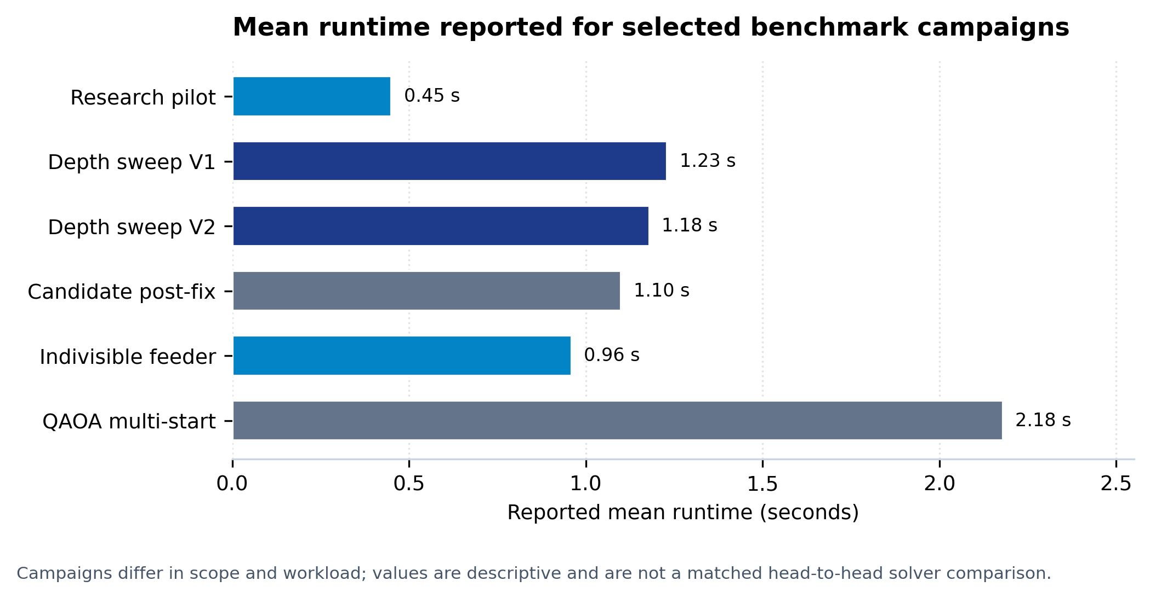
Figure 1. Mean runtime across benchmark campaigns. The campaigns use different workloads and therefore provide descriptive context rather than a controlled, same-instance comparison.

The classical scaling comparison shows a substantial runtime increase for the tested branch-and-bound (B&B) implementation as feeder count increases. Mean runtime rose from 3.07 ms at 10 feeders to 5,827.09 ms at 20 feeders, approximately a 1,900-fold increase. The runtime for 30 feeders was projected to exceed 1.6 hours; this is an extrapolation rather than a measured result. By comparison, HiGHS returned optimal solutions for all 50 instances in the scalability campaign, covering up to 200 feeders, with a reported mean runtime of 21.3 ms at 200 feeders. These results indicate that HiGHS was the more efficient practical baseline for the tested cases; the B&B timings should not be interpreted as a general limit on classical optimization.
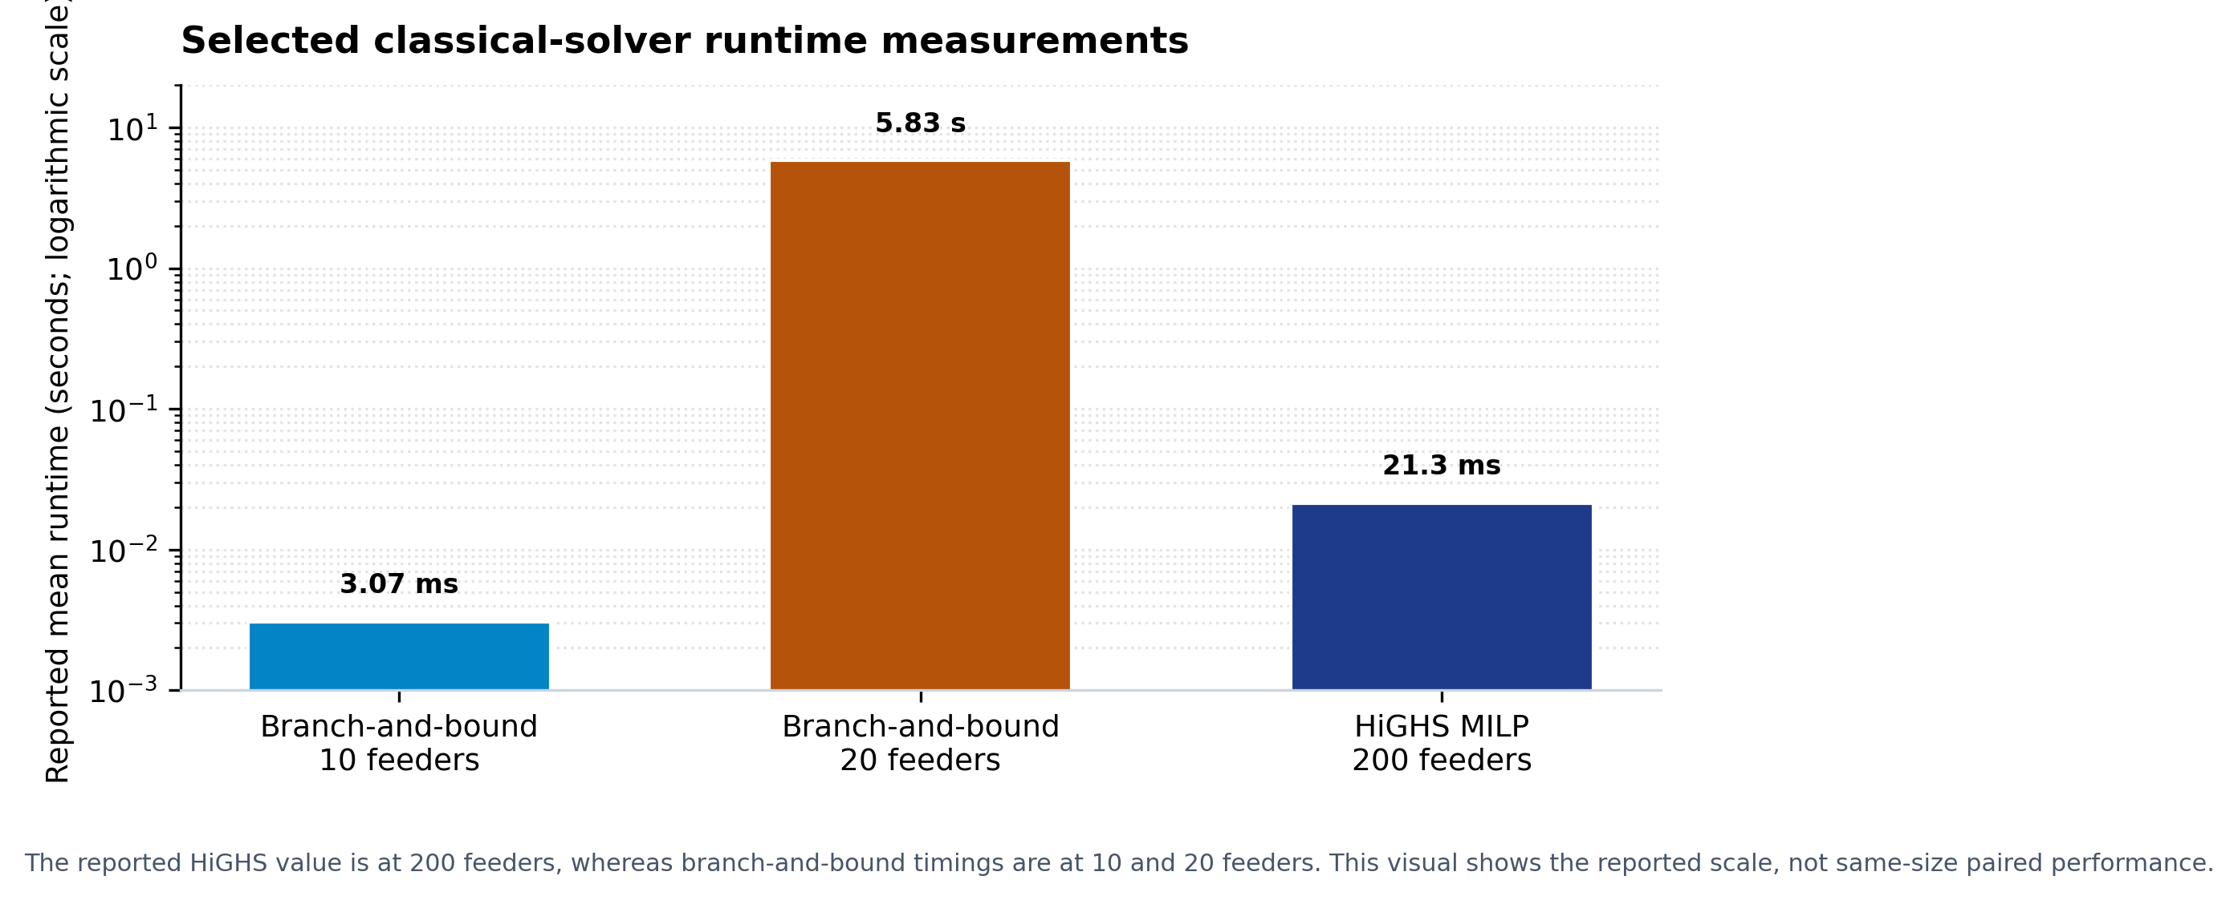
Figure 2. Selected classical-solver runtimes on a logarithmic scale. Feeder counts differ across the plotted observations, so the figure illustrates scaling behaviour rather than a paired comparison at identical problem sizes.
Overall, these experiments do not demonstrate a quantum computational advantage. The small-instance QAOA experiments establish a useful testbed for encoding microgrid allocation as a variational optimization problem, while classical MILP remains the stronger practical baseline for the tested range. The reported runtimes are software benchmark results from classical execution environments, not measurements of a physical quantum processor.

2. Energy Allocation
The snapshot allocation model distributes a limited supply S among loads with demands Dᵢ and priority weights wᵢ. The model minimizes the weighted penalty associated with unmet demand. In the continuous formulation, each load may receive any allocation between zero and its requested demand:
Minimize J_cont(x) = Σᵢ wᵢ(Dᵢ − xᵢ)
Subject to Σᵢ xᵢ ≤ S, 0 ≤ xᵢ ≤ Dᵢ for every load i
Because the marginal reduction in penalty per additional unit of power is determined by wᵢ, the continuous model is solved exactly by sorting loads in descending order of priority and allocating power in that order until supply is exhausted or all demands are met. The priority weights represent service importance rather than physical power; the illustrative hierarchy uses weights of 1000, 100, 10 and 1 for critical, high, medium and low priority classes, respectively.
Indivisible feeder switching is different because each feeder must be either fully energized or shed. Let bᵢ = 1 denote an energized feeder and bᵢ = 0 a shed feeder. The corresponding objective is:
Minimize J_indiv(b) = Σᵢ wᵢDᵢ(1 − bᵢ)
Subject to Σᵢ Dᵢbᵢ ≤ S, bᵢ ∈ {0, 1}
This binary model is a 0/1 knapsack problem. Unlike the continuous case, selecting feeders only by priority weight need not use the available capacity efficiently; an exact combinatorial reference is therefore required to assess solution quality. We evaluated QAOA on instances containing three to six feeders encoded with five to nine qubits. The feeder-switching campaign recorded 68 ground-state hits in 72 trials (94.44%) and 100% feasibility. These results characterize the tested small instances and should not be generalized to larger networks without further experiments.
Mode | Decision variables | Core constraint | Solver used in this study | Interpretation
Continuous snapshot allocation | Real-valued xᵢ (kW) | Σxᵢ ≤ S; 0 ≤ xᵢ ≤ Dᵢ | Priority greedy; classical MILP | Greedy is exact for the continuous fractional-knapsack model.
Indivisible feeder switching | Binary bᵢ ∈ {0,1} | ΣDᵢbᵢ ≤ S | Exact B&B / HiGHS reference; QAOA on small cases | 0/1 knapsack; priority-only greedy is not generally exact.
24-hour dynamic dispatch | 218 continuous variables | Hourly energy, battery, import and load constraints | SciPy HiGHS linear programming | Separate classical dispatch module; not a QAOA result.
Table 2. Optimization formulations and solution methods used in the study. Supply and physical power allocations are measured in kW, whereas J is a weighted objective score.
The 24-hour dynamic-dispatch module addresses a separate scheduling problem involving solar generation, battery charging and discharging, time-of-use grid imports, and flexible industrial loads over 24 hourly periods. The model contains 218 continuous variables and is solved using SciPy HiGHS linear programming. Accordingly, the QAOA findings discussed here apply to snapshot allocation and small indivisible-switching instances, not to 24-hour dispatch.

3. Objective Value
The objective value J is the weighted penalty associated with unmet demand. In the formulations considered here, it is a score used to rank allocations and is not reported as a physical quantity such as kW or kWh. Physical allocations xᵢ and the supply constraint are expressed in kW. Lower objective values indicate better allocations. Z*₍disc₎ denotes the exact optimal objective value for the matching discrete or discretized model and serves as the reference for evaluating candidate solutions.
For a candidate with objective value J, the reported normalized optimality gap is calculated as:
Gap (%) = 100 × (J − Z*₍disc₎) / max(1, |Z*₍disc₎|)
A gap of 0% indicates that the candidate matches the exact discrete reference objective. A positive gap indicates a worse objective under the same formulation. Objective value and optimality gap complement feasibility and runtime: a candidate may satisfy every constraint without being optimal, and a fast solution is not necessarily a high-quality one.
The reference optimum must correspond to the same formulation as the candidate. The continuous optimum can differ from the discrete optimum because discretizing power or requiring all-or-nothing feeder decisions restricts the set of permitted allocations. We therefore evaluate QAOA candidates against the matching discrete reference rather than the continuous optimum.
Quantity | Meaning | Units / scale | How to interpret it
J or J_indiv | Candidate weighted unmet-demand penalty | Dimensionless | Lower is better; not kW or kWh.
Z*₍disc₎ | Exact optimum for the matching discrete/chunked model | Dimensionless | Reference value for judging the candidate under the same formulation.
Optimality gap (%) | 100 × (J − Z*₍disc₎) / max(1, |Z*₍disc₎|) | Percent | 0% means objective parity with the exact discrete reference; positive means worse objective.
Feasibility | Whether allocated/energized load stays within supply and variable bounds | Boolean check; supply in kW | A feasible solution can still be suboptimal.
Table 3. Definitions of the objective, reference optimum, optimality gap and feasibility metrics.

4. Probability Distribution
QAOA encodes the combinatorial objective using a QUBO/Ising formulation and generates a probability distribution over candidate bitstrings [1–3]. Circuit depth p determines the number of alternating cost and mixing layers. In the small indivisible-feeder campaign, increasing p from 1 to 3 was associated with a 74.4% increase in the mean statevector probability mass assigned to the ground-state subspace. This result indicates greater simulated concentration on optimal states for the tested instances, but does not establish an advantage over classical optimization.
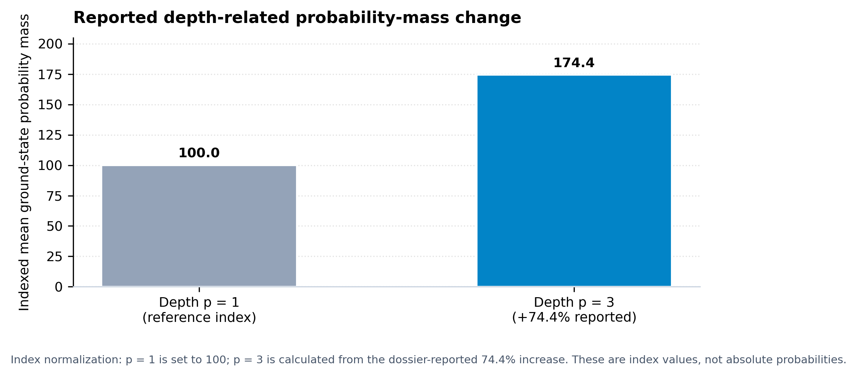
Figure 3. Relative ground-state probability-mass index normalized to p = 1. The p = 3 index reflects the reported 74.4% relative increase; it is not an absolute probability.
Each trial used 2,048 measurement shots. We distinguish (i) statevector probability assigned to an optimal state, (ii) empirical frequency of an optimal bitstring in the measured register, and (iii) the proportion of benchmark trials in which the optimum was discovered. These quantities are related but not interchangeable. In the corrected depth-sweep campaign, the optimum was reported in the raw measurement register in 59 of 60 trials (98.33%). The legacy production pipeline recorded 52 successful trials out of 60 (86.67%). The two values refer to different stages of the workflow and should not be interpreted as equivalent measures of production-solver accuracy.
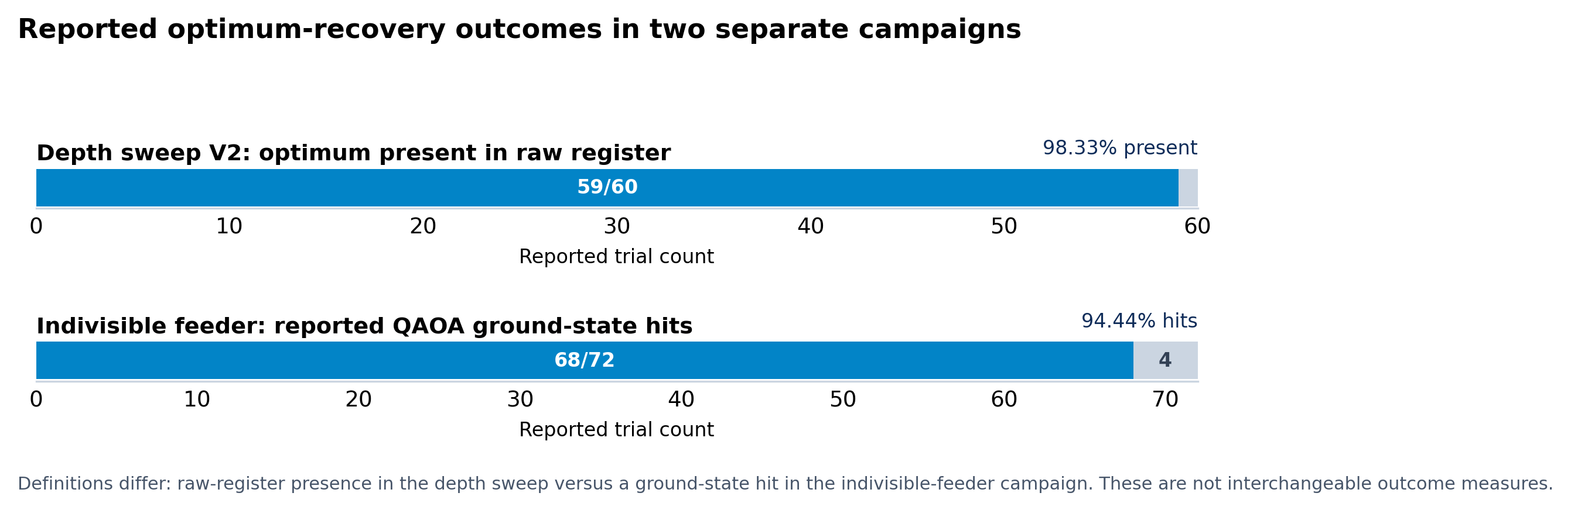
Figure 4. Optimum-recovery counts from the corrected raw-register depth sweep and the legacy production campaign. The success definitions differ between campaigns.
The Qiskit Optimization conversion pathway applies a frequency-based filtering step to measured bitstrings. If a bitstring occurs c times in 2,048 shots, its empirical frequency is f = c/2048; the pathway compares f² with a threshold of 10⁻⁶. Under this rule, bitstrings observed once or twice are filtered out, whereas a bitstring observed three times is retained. An optimal bitstring can therefore appear in the raw register yet be absent from the candidate pool passed to the solver. For reproducibility, raw measurement outcomes, inspected candidates and the final selected solution should be tracked as distinct stages.
Occurrences in 2,048 shots (c) | Empirical frequency (c/2048) | Squared frequency, f² | Filtering outcome
1 | 0.0004883 | 2.38 × 10⁻⁷ | Filtered out (< 10⁻⁶)
2 | 0.0009766 | 9.54 × 10⁻⁷ | Filtered out (< 10⁻⁶)
3 | 0.0014648 | 2.15 × 10⁻⁶ | Retained (> 10⁻⁶)
Table 4. Examples of the frequency-squaring threshold for bitstrings observed in 2,048 measurement shots.

5. Limitations
The QAOA experiments are small-scale statevector simulations executed on classical CPUs. The tested instances contain only a few loads or feeders and approximately four to eleven qubits in the snapshot-allocation experiments. No physical quantum-hardware experiments were conducted; hardware noise, decoherence, gate infidelity and device-level execution costs therefore remain outside the scope of this evaluation. The results do not establish quantum advantage.
The classical comparison constrains the practical interpretation of the results. HiGHS solved all 50 instances in the reported scalability campaign, including instances with up to 200 feeders, while the runtime increase observed for B&B is specific to the tested implementation and instances. It does not prove that all classical methods become inefficient at the same problem size. For the current test range, classical MILP is the stronger practical baseline, and QAOA serves as a testbed for studying variational problem encodings and optimization behaviour.
The benchmark campaigns use controlled scenarios, selected random seeds and specified optimizer settings. Their results characterize these experiments but do not establish performance under every real-world condition, including uncertain demand, changing renewable generation, live feeder telemetry, network power-flow constraints or field operation. The 24-hour dispatch module is a separate classical linear program and is not evidence of QAOA performance. In addition, the reported 74.4% probability-mass change is a relative increase; absolute probabilities are not presented here because they are not available in the summarized results. Further work should report absolute ground-state probabilities alongside shot-based frequencies and trial-level hit rates.

References Cited in This Section
[1] E. Farhi, J. Goldstone, and S. Gutmann, “A Quantum Approximate Optimization Algorithm,” arXiv:1411.4028, 2014.
[2] A. Lucas, “Ising formulations of many NP problems,” Frontiers in Physics, vol. 2, article 5, 2014.
[3] F. Glover, G. Kochenberger, and Y. Du, “A tutorial on formulating and using QUBO models,” 4OR, vol. 17, no. 4, pp. 339–371, 2019.
[4] Q. Huang et al., “Quantum computing for power systems: A review and perspective,” IEEE Transactions on Power Systems, vol. 36, no. 6, pp. 5700–5712, 2021.

